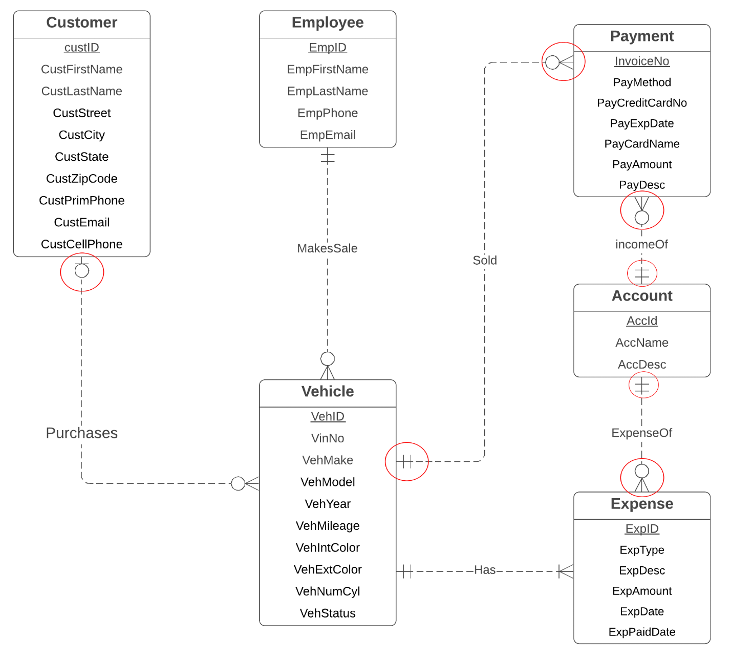**Problem 2**

**Corrected Diagram:**

**Error List:**

* The identifying IncomeOf relationship must have a minimum cardinality of 1 for *Account*. Identifying relationships cannot be optional for the child entity type.
* *Account* should not be a weak entity type as the narrative indicates that AcctId is unique. If *Account* is a regular entity type, the IncomeOf and ExpenseOf relationships should be regular, not identifying.
* The cardinality of IncomeOfis reversed. The narrative indicates that each payment has an account and accounts are related to a collection of payments.
* The cardinality of ExpenseOf is reversed. The narrative indicates that each expense has an account and accounts are related to a collection of expenses.
* The minimum cardinality of MakesSale should be 0 for *Vehicle*. The narrative indicates that a vehicle can remain on the lot some days before a sale is made.
* The minimum cardinality of *Sold* should be 0 for *Vehicle*. The narrative indicates that a vehicle can remain on the lot some days before a sale and related payments are made.
* The *Process* relationship is redundant with the MakesSale and *Sold* relationships. The narrative indicates that the same employee makes the sale and processes the payment.
* The minimum cardinality of *Purchases* should be 0 for *Vehicle*. The narrative indicates that a vehicle can remain on the lot some days before a sale and related payments are made. Before sale, a vehicle is not related to a customer.